City table

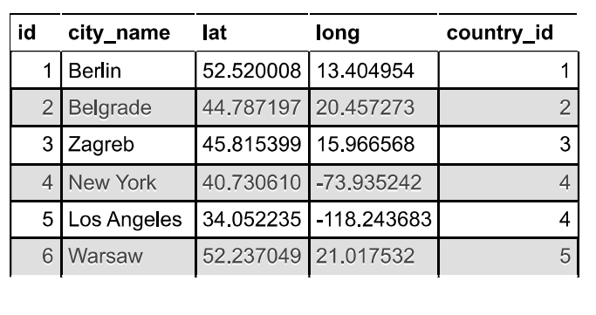

Customer table

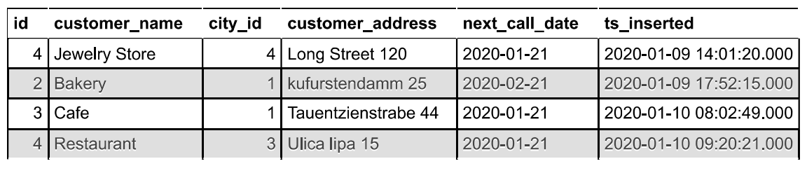

Country table

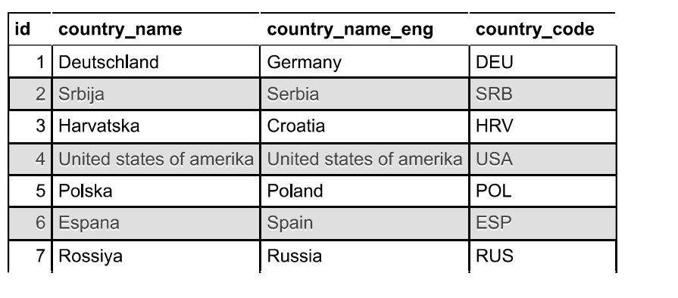

Task : 1 (join multiple tables using left join)

List all Countries and customers related to these countries.

ans:

SELECT customer.customer_name,country.country_name FROM customer LEFT JOIN country ON customer.id = country.id

For each country displaying its name in English, the name of the city customer is located in as

well as the name of the customer.

ans:

SELECT

country.country_name_eng,

city.city_name,

customer.customer_name

FROM

country

LEFT JOIN

city

ON

Country.id = city.id

LEFT JOIN

customer

ON

city.id = customer.id;

Return even countries without related cities and customers.

ans:

SELECT

country.country_name,

NULL AS city_name,

NULL AS customer_name

FROM

country

WHERE

country.id NOT IN (SELECT DISTINCT id FROM city)

AND country.id NOT IN (SELECT DISTINCT id FROM customer);

Task : 2 (join multiple tables using both left and inner join)

Return the list of all countries that have pairs(exclude countries which are not referenced by any

city). For such pairs return all customers.

ans:

SELECT

country.country_name,

city.city_name,

customer.customer_name

FROM

country

LEFT JOIN

city

ON

country.id = city.id

INNER JOIN

customer

ON

city.id = customer.id

WHERE

city.id IS NOT NULL;

Return even pairs of not having a single customer

ans:

SELECT

country.country_name,

city.city_name,

customer.customer_name

FROM

country

LEFT JOIN

city

ON

country.id = city.id

LEFT JOIN

customer

ON

city.id = customer.id

WHERE

customer.customer_name IS NULL